1. Inventory tracking with alerts leading to centralized inventory via refill and restock.

**Scripts to execute Batches:**

NotifyLowStockProductsBatch batch=new NotifyLowStockProductsBatch();

Database.executeBatch(batch);

1. Demand forecasting using custom built calculator

Scripts for Batch Jobs to calculate recommendations

UpdateRecommendedPeakDateBatch batch = new UpdateRecommendedPeakDateBatch();

Database.executeBatch(batch);

1. Expiry notifications  and real time alerts across email for waste management

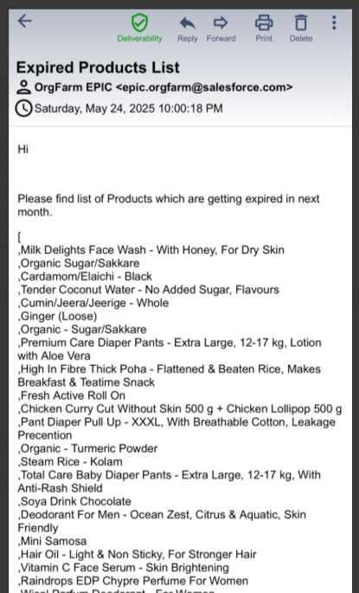

1. Automation of restocking decisions

1. Discounts and offers

Discounted price for Products which are going to expire.

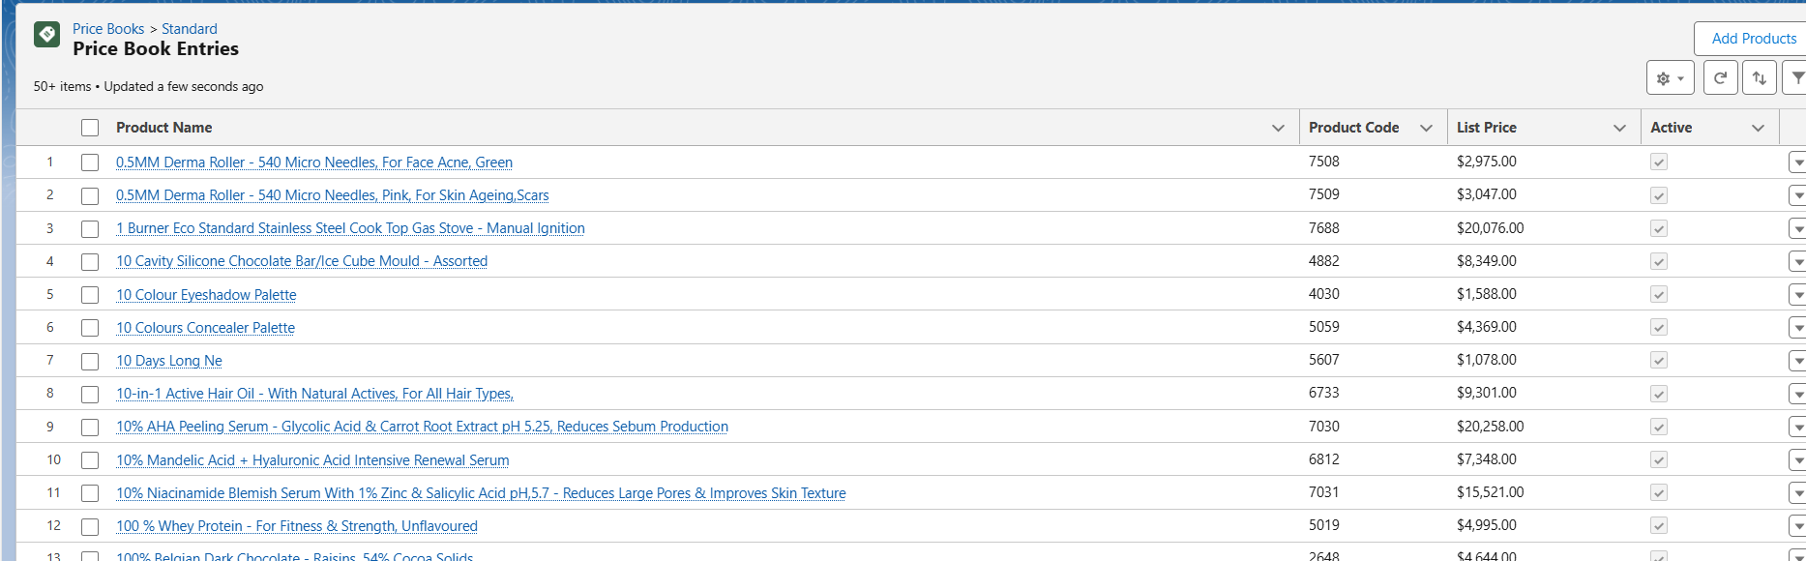

6)Customizable Dashboards:

